REVIEW EXERCISES

MM 0703, Lesson 4

Circle the letter of the correct answer to each question.

1. What is the current and voltage relationship immediately after the switch is closed in the circuit in figure 4-27, which shows a capacitor charging?

a. Current and voltage are maximum.
b. Current and voltage are minimum.
c. Current is minimum and voltage is maximum.
d. Current is maximum and voltage is minimum.

2. What is the resulting action if switch (S) is opened after the capacitor (C) is fully charged? Se figure 4.27.

a. C loses its charge immediately.
b. C loses its charge gradually.
c. C maintains its charge through the electrostatic field.
d. C maintains its charge through the magnetic field.

3. What occurs when switch S is closed in this circuit where a capacitor is discharging (figure 4-28)? Assume C fully charged.

a. C loses its charge but retains its electrostatic field.
b. C loses its charge but retains its magnetic field.
c. Current and voltage decrease from maximum to zero.
d. Current and voltage increase from zero to maximum.

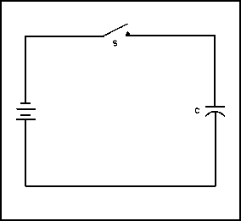

Figure 4-27. Charging a Capacitor.
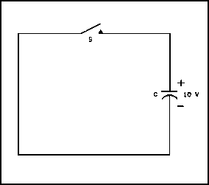

Figure 4-28. Discharging a Capacitor.

99
4. What symbol indicates a capacitor’s ability to store electrical energy?
MM 0703, Lesson 4

a. C.
b. Xc.
c. E.
d. Ex.

5. What formula is used to compute the charge on a capacitor?

a. Q = Ce.
b. Q = CE.
c. 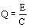
d. Q = Ec.

6. What best describes a PURELY inductive circuit?

a. Counter EMF and the applied voltage are in phase.
b. Current leads the applied voltage by 90°.
c. Current lags the applied voltage by 90°.
d. Counter EMF and the current are in phase.

7. Why are laminated iron cores used in inductors?

a. To reduce the inductance.
b. To reduce flux linkage.
c. To reduce reactance.
d. To reduce power losses.

8. From which formula is the total capacitance of two series-connected capacitors derived?

a. 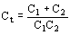
b. 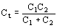
c. Ct = C1C2.
d. Ct = C1 + C2.

9. How is the total capacitance determined for any number of series-conntected capacitors?

a. Ct = C1 + C2 + C3.
b. 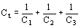
c. 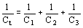
d. 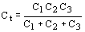

100
10. What is the voltage drop relationship between two unequal capacitors connected in series?
MM 0703, Lesson 4

a. The larger capacitor drops the least voltage.
b. The smaller capacitor drops the least voltage.
c. The voltage drops are equal.
d. The voltage drops depend on the frequency.

11. What formula is used to compute the capacitance of parallel-connected capacitors?

a. 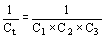
b. 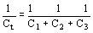
c.
d. Ct = C1 + C2 + C3.

12. What is the reactance, in ohms, of a 20 pfd capacitor at 30 MHz?

a. 265.
b. 26.5.
c. 2.65.
d. 0.265.

13. The largest voltage will be dropped across which capacitor in the circuit in figure 4-29, which shows capacitors in series.

a. 8 µfd.
b. 5 µfd.
c. 3 µfd.
d. 2 µfd.

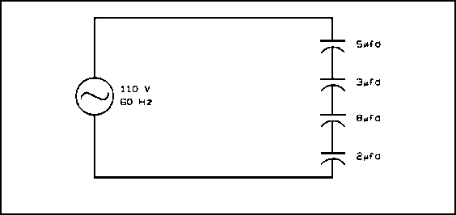

Figure 4-29. Capacitors in Series.

101
14. What is the impedance, in ohms, of the series circuit in figure 4-30?

MM 0703, Lesson 4

a. 7.
b. 5.
c. 3.
d. 1.

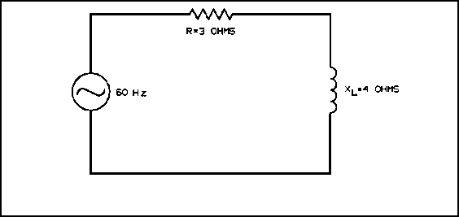

Figure 4-30. Series Circuit.

15. What is the phase relationship between current and voltage when a sine wave of voltage is applied to a capacitor?

a. Current lags voltage by 90°.
b. Current lags voltage by 45°.
c. Current leads voltage by 90°.
d. Current leads voltage by 45°.

16. What best describes mica capacitors?

a. Unsuitable for high frequency circuits.
b. Unstable under temperature changes.
c. Unsuitable for high voltage circuits.
d. Stable under temperature changes.

17. What is the most widely used type of capacitor?

a. Ceramic polished.
b. Mica.
c. Air.
d. Impregnated paper.

102
18. If the values of inductance and frequency are doubled, how is inductive reactance affected?

a. Unchanged.
b. Doubled.
c. Reduced to one half the original value.
d. Increased to four times the original value.

19. What is the power dissipated by the resistor in an RC circuit when 100 W of apparent power is delivered to the circuit, if the power factor is 0.8?

a. 0.008 W.
b. 8 W.
c. 80 W.
d. 100 W.

20. What is a characteristic of an inductor?

a. It opposes a change in voltage.
b. It opposes a change in current.
c. It aids a change in voltage.
d. It aids a change in current.

Recheck your answers to the Review Exercises. When you are satisfied that you have answered every question to the best of your ability, check your answers against the Exercise Solutions. If you missed five or more questions, you should retake the entire lesson, paying particular attention to the areas in which your answers were incorrect.

103

